**ALTERNATIVE INVESTMENTS**

Table of Contents

Reading 50: Fixed-Income Securities: Defining Elements 3

a. Describe basic features of a fixed-income security 3

b. Describe content of a bond indenture 3

c. Compare affirmative and negative covenants and identify examples of each 3

d. Describe how legal, regulatory and tax considerations affect the issuance and trading of fixed income securities 3

# Reading 58: Introduction to Alternative Investments

## Compare alternative investments with traditional investments

Compared to traditional investments, alternative investments exhibit:

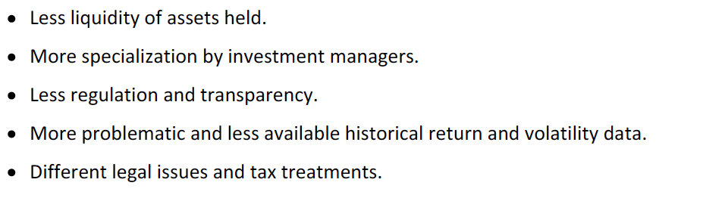

## Describe categories of alternative investments

* Hedge funds: may use leverage, hold long and short positions, use derivatives and invest in illiquid assets.
* Private equity funds: invest in equity that is not publicly traded or in the equity of publicly traded firms that the funds intends to take private. They use LBOs in lots of cases but there are also venture capital funds that invest in unproven companies at the early stages of their existence.
* Real estate: include residential or commercial properties as well as real estate backed debt.
* Commodities: physically owning them, through derivatives or through the equity of the commodity producing firm.
* Infrastructure: long0lived assets that provide public services.
* Other: investments in tangible collectible assets and intangible assets like patents.

## Describe potential benefits of alternative investments in the context of portfolio management

Over long periods return from alternative invest have had low correlations with the ones of traditional investments, which might help to reduce the risk on an overall portfolio. They have also been higher (a reason may be that the markets are less efficiently priced, offering extra returns)

Traditional risk measures may not be adequate to capture the risk of the returns from these assets. Measures such as worst month or historical frequency of downside returns are used.

Surviving bias: refers to the bias created from only using existing firms for an analysis (excluding failed firms).

Backfill bias: bias created from only using assets that are part of an index.

## Describe hedge funds, private equity, real estate, commodities, infrastructure and other alternative investments including, as applicable, strategies, sub-categories, potential benefits and risks, fee structures and due diligence

**Hedge funds**

They can use leverage, take short equity positions and use derivatives.

They trade through prime brokers.

The objectives of the fund are set either on an absolut or a relative basis.

They are less regulated and are usually set up as limited partnerships.

The management firm receives both management and incentive (based on returns) fees.

Redemption restrictions include a lockup period (not allowed withdrawals for a certain time after the initial investment) and/or notice period (the time the fund has to fulfill the redemption request after receiving it (typically 30-90 days)). Fees are also charged but may decrease the value of partnership interests.

Fund of funds: invest in hedge funds, creating a diversified portfolio that allows smaller investors to access hedge funds. The funds charge additional fees to the ones of the hedge funds.

Hedge fund strategies (hedge funds classification):

* Event-drive strategies: based on corporate restructuring or acquisitions that create profit for long or short positions in common equity, preferred equity or debt:
  + Merger arbitrage: buy the shares of the firm being acquired and sell short the firm making the acquisition.
  + Distressed/restructuring: Buy financially distressed companies when analysis suggest that the value could be increased with a successful restructuring.
  + Activist shareholder: buy sufficient equity to influence a company’s policies with the goal of increasing the value of the firm.
  + Special situations: invest in the securities of firms issuing or repurchasing securities, spinning off divisions, selling assets or distributing capital.
* Relative value strategies: Buy a security and sell short a related security to profit the resolution of price discrepancy between the two.
  + Convertible arbitrage fixed income: exploit discrepancies between convertible bonds and common stock.
  + Asset-backed fixed income: exploit discrepancies among MBS and ABS.
  + General fixed income: exploit discrepancies between different types of fixed income securities.
  + Volatility: exploit discrepancies arising from differences between returns volatility implied by options prices and manager expectations of future volatility.
  + Multi-strategy: exploit other discrepancies from the mentioned before.
* Macro strategies: based on global trends and events investing in different instruments.
* Equity hedge fund strategies: seek to profit from long and short positions in public equity or derivatives whose underlying asset is a publicly traded equity.
  + Market neutral: take long and short position from undervalued and overvalued stocks in approximately equal amounts to reduce market risk.
  + Fundamental growth: find high-growth companies and buy.
  + Fundamental value: buy undervalued stocks.
  + Quantitative directional: based on technical analysis, buy undervalued and sell overvalued stocks.
  + Short bias: have an overall negative market exposures from equities (being short).

Hedge fund potential benefits and risks:

* Better returns.
* Lag the returns of global equities in up markets.
* Correlations with global equity returns tend to increase during financial crisis.

Hedge fund due diligence:

The selection requires significant investigation as the hedge funds do not require to disclose as much information. Factors to consider:

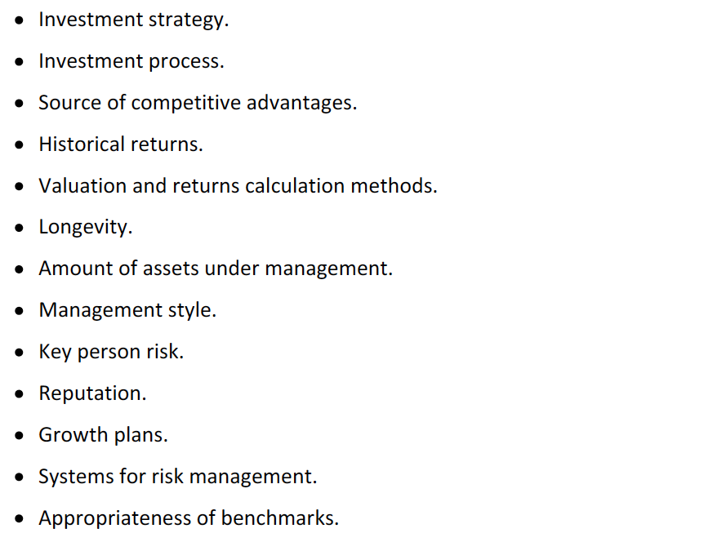

**Private equity**

Invest either in private companies or public companies they intend to take private, or in early stage companies. The other two smaller categories are distressed investment funds and development capital funds.

Private equity strategies:

* Leveraged buyouts (LBOs): are the most common type. Using either bank debt, high-yield bonds or mezzanine finance (debt that are subordinate to the high-yield bonds and carry conversion features) the funds buy companies. Types:
  + Management buyouts (MBOs): the existing management team is involved in the purchase.
  + Management buy-ins (MBIs): an external management team replaces the existing one.

The objective is to increase the value of the firm. Companies with high cash flows are great candidates since the cash can be used to pay the taken debt.

* Venture capital (VC): invest in companies in early stages of their development. It is often done in the form of equity but also found in the form of convertible preferred shares r convertible debt. The firms in which the fund is invested are known as portfolio companies and the fund managers are closely involved in the development of the company (sitting in the board). Categorization of venture capital investment goes as follows:

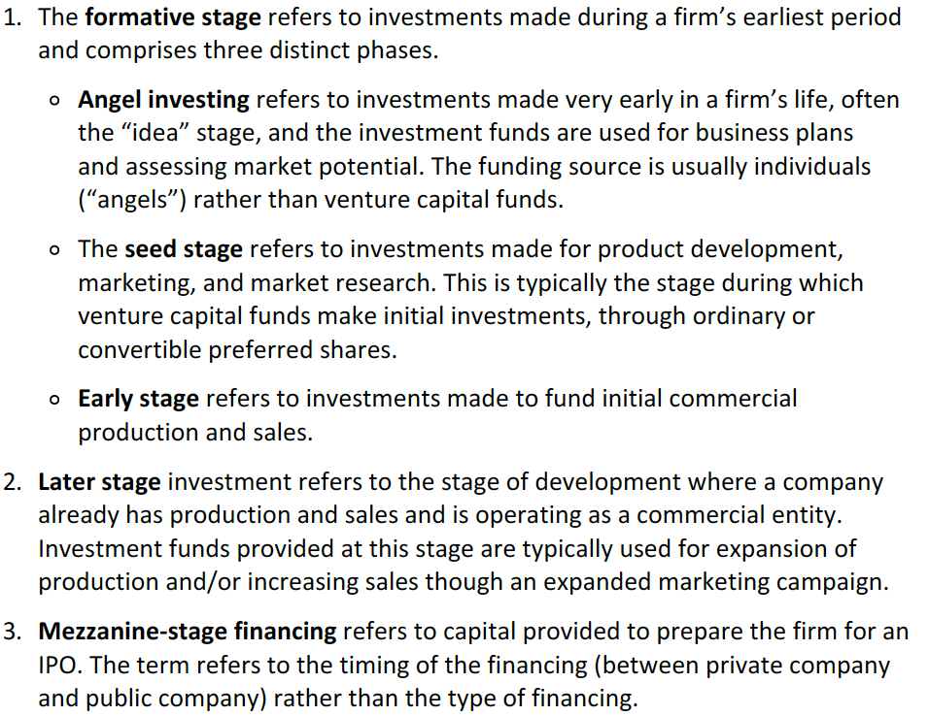

* Developmental capital or minority equity investment: provision of capital for business growth or restructuring (for public companies the investments are referred as private investment in public equities (PIPEs)).
* Distressed investing (vulture investors): buy debt of mature companies that are experienced financial difficulties. Investors then take an active role on the turnaround of the company working with the management.

Structure and fees:

* Are usually structures as limited partnerships.
* Committed capital is the capital provided by investors to the fund which is invested as opportunities appear (drawn down), usually 3-5 years.
* Fees go from 1-3%.
* Incentive fees are typically 20% of profits but are not earned until the initial capital is returned to investors.
* Clawback provision.

Private equity exit strategies:

The average holding period of portfolio companies is five years. The methods to exit are:

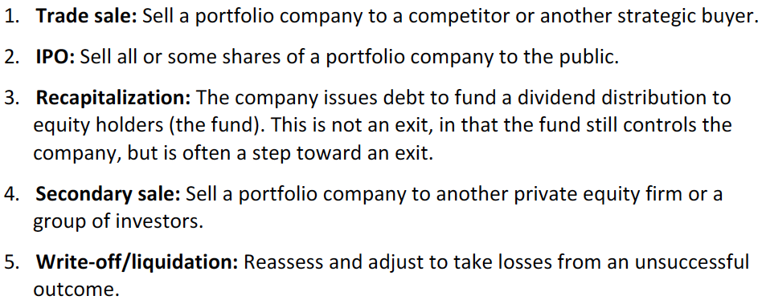

Private equity potential benefits and risks:

* Higher returns than stock markets.
* Less-than-perfect correlation with other traditional investments.
* Higher standard deviation than stock markets.
* Data may suffer survivorship and backfill bias.

Private equity due diligence:

* Interest rate and availability of capital must be considered as leverage is commonly used.
* Choice of manager is really important. Look at his experience, valuation methods used, incentive fee structures and drawdown procedures.

**Real estate**

Income comes in the form of rent and capital gains. Provide diversification and inflation protection.

Forms of real estate investment:

* Residential property: investing in real estate is usually made using leverage where the residual value is the owners’ equity. The described situation is a direct investment. The mortgage issuer also holds a direct investment. MBS represent an indirect investmet.
* Commercial real estate: refer to the homes purchased for rental income. Large properties like office buildings, are also an investment in commercial property. It is important that log time horizons, illiquidity, large size of investment needed and complexity are factors to be considered. Vehicles such as limited partnerships or real estate trust (REIT) are other ways to invest. Mortgage issuers are considered direct investors and CMBS holders are indirect investors.
* REITs: issue publicly traded shares and are identified by the type of real estate asset that they hold. Income is used to pay dividends. About 90% of the income is distributed to avoid income taxes to be paid from the REIT.

Other real estate assets:

* Timberland: income comes from sales of timber.
* Farmland: income comes from sales of agricultural products.

Changes in land and commodity (the one that is sold) prices affect both.

Potential benefits and risks of real estate:

* Performance is measured by:
  + Appraisal index: based on periodic estimates of property values.
  + Repeat sales index: based on price changes for properties sold multiple times.
  + REIT indices: based on actual trading prices of REIT shares.
* Correlation between REIT indices and stock markets are relatively strong but weak when compared to the bond market.

Real estate investment due diligence:

* Global and national economic factors, local market conditions and interest rate levels affect the properties values.
* Manager abilities.
* Degree of leverage.
* For distressed properties and real estate development there are certain additional risk factors.

**Commodities**

Although investors can invest directly in commodities, derivatives are the most commonly used instruments to gain exposure to commodity prices. This happens because commodities involve storage and transportation costs.

Return is based on price changes, not income streams.

Futures and some options trade on exchanges while other options, swaps and forwards are traded OTC.

Other methods of exposure include:

* ETFs: they can be invested in commodities.
* Equities that are directly linked to a commodity: the issue with this method is that the behavior of price of the stock and the commodity might not be perfectly correlated.
* Managed future funds (actively managed, limited partnership…).
* Individual managed accounts.
* Specialized funds in specific commodity sectors.

Potential benefits and risks of commodities:

* Returns have been lower than global stocks or bonds.
* Low sharpe ratios.
* Correlations with global equities and bonds have been typically less than 0.2.
* Prices tend to move with inflation, which might provide a hedge.

Commodity prices and investments:

* Function of supply (affected by production and storage costs and existing inventory) and demand (affected by the value to end-users and global economic conditions and cycles).
* Lots of time the supply is inelastic in the short run making prices really volatile to demand changes.
* …

**Infrastructure**

Include transportation and utility assets. Other categories are communications and social.

Brownfield investments -> when the investment is done over an already constructed asset. High yields, stable cash flows but little growth potential.

Greenfield investments -> when the investment is done over assets that are about to be constructed. More uncertainty, lower yields but higher growth potential.

Investment involves purchasing or construction and selling, leasing or operating the asset.

High initial investment, fixed costs and low liquidity. However, there are publicly traded vehicles for investing.

**Other alternative investments**

Collectibles. There is no income generation. Storage costs may be significant and special knowledge might be required. This markets may be illiquid and there are only capital gains.

## Describe, calculate and interpret management and incentive fees and net-of-fees returns of hedge funds

Management fee – earned regardless the performance.

Incentive fees – Portion of the profits.

For instance, the most common fee structure known as 2 and 20 or 2 plus translates to a 2% management fee over the assets managed plus an incentive fee of 20%. For funds of funds is 1 and 10.

Profits are gains in value, gains in value excess of the management fee or gains in excess of a hurdle rate (a benchmark rate where profits are only subject of incentive fee if the returns are higher than this rate, it can be a percentage or relative to a benchmark. A hard hurdle rate means that only profits on excess to the hurdle are subject of incentive fee while a soft hurdle means that all of the profits are subject of the fee when the rate is met),

High water mark -> situation where incentive fees are only applicable if there is new profit made for the investor. So, if the investment of an specific investor increases 5, he would be charge an incentive fee for those five. If it then decreases two and increases three, only one dollar will be subject of the fee.

Fees can be calculated based on either beginning or end of period values.

Incentive fees may be calculated net of management fees or independent of management fees.

Incentive fee net of management fee and with a hard hurtle rate = (ending value – initial value – (initial value * hurtle rate)) * incentive fee rate.

Incentive fee net of management fee and with a soft hurtle rate = (ending value – initial value – (initial value * hurtle rate)) * incentive fee rate) if it is positive, the incentive fee = (ending value – initial value)) * incentive fee rate)

*if there is a high water mark, it should be accounted for.

## Describe issues in valuing and calculating returns on hedge funds, private equity, real estate, commodities and infrastructure

**Hedge fund valuation**

For exchange traded securities there is no issue (close prices, bid for long positions and ask for short positions or averade) but for non-traded securities model values are used. Sometimes the trading NAV is used to ajust for illiquidity.

**Private equity company valuation**

Using comparable: use multiples of similar companies.

DCF approach: a dividend discount model or discounting FCF or FCFO.

Asset-based approach: using either liquidation (it should be low since it considers that the assets are sold in a situation of financial distress) or fair values for valuing assets.

**Real estate valuation**

Methods:

* Compable sales approach: uses recent similar transactions and makes adjustments to the value for age, location, condition and size.
* Income approach: calculating the present value of expected cash flows or by dividing the net operating income for a property by a capitalization rate (is a discount rate minus a growth rate and is estimated based in general business conditions, property qualities, management effectiveness and sales of comparable properties.
* Cost approach: uses the replacement cost of a property, which considers buying the land and rebuilding the house at current prices.

For REITs, one measure of cash flow is funds from operations (FFO) calculated as net income plus depreciation minus gains from property sales and plus losses on preperty sales (because gains and losses are nonrecurring). Another measure is adjusted funs from operations (AFFO) which is FFO minus recurring capital expenditures.

**Commodity valuation**

Future price ≈ spot (1+risk free) +storage costs – convenience yield

Convenience yield is the value gain from owning and using the asset prior to the future date.

Contango: when the convenience yield is so small that furutre prices are higher than spot prices.

Backwardation: when convenience yield is high and future prices are less than spot prices.

Sources of commodities future returns:

* Roll yield: yield due to a difference between spot and future prices or the different between two future prices with different expiration dates. Is positivie for backwardation and negative in contango.
* Collateral yield: interest earned on collateral required to enter into future contracts.
* Change in spot prices.

## Describe risk management of alternative investments

Most important risk considerations:

* Standard deviation may be misleading because returns are not approximately normal (tend to be leptokurtic and negatively skewed) and because of the use of estimated values, the standard deviation will be understated. It may be appropriate for publibly traded securities.
* VaR could be more appropriate or Sortino ratio (measures risk as downside deviation rather than standard deviations).
* Derivatives introduces operational, financial, counterparty and liquidity risk.
* Management underperformance is another risk that should be accounted for.
* Hedge and private equity funds are less transparent that traditional funds.
* Illiquidity is high which should be reflected in a premium.

Due diligence:

